COP 21, Round One:
Battle Lines Are Drawn

A Report on the Global Climate March and the Opening of the Paris COP 21 Negotiations

John Foran

December 3, 2015

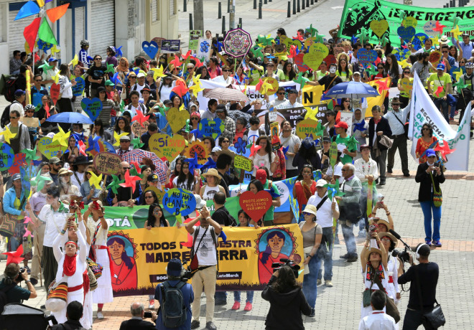
The Climate March in Bogotá, Colombia. Photo by Jose Miguel Gomez for Reuters

The much-anticipated UN climate summit COP 21 kicked off in Paris on the last weekend of November as heads of state, national delegations, activists, NGOs, and journalists took up residence in a city whose world had been shattered just two weeks before by suicide bombs taking 129 lives. The French government decided that while the COP would go on as planned, the climate movement’s plans for mass demonstrations to bookend the start and finish of the talks would not. This seemed strange, as concerts, Christmas fairs, and sporting events in large public venues were allowed to continue, and in fact, all that was banned was the gathering of two or more people for the purposes of a public event with political content. This has changed the story of the summit from the outset, and decidedly not for the better.

Sunday’s Climate Marches: the missing million
So on Saturday and Sunday, November 28 and 29, climate marches were held around the world to try to send the messages to global leaders that those in Paris could not. May Boeve of 350.org, one of the principle organizations behind the day, reported that no less than 785,000 marched and demonstrated and made themselves colorful in at least 2,300 cities in over 175 countries, marking November 29, 2015 as one of the greatest days of climate action mobilization ever. The 50,000 mark was surpassed or approached in London and Melbourne, but it was the fact that so many places came out on the day that made it significant. One of the central demands of the mobilization was “Keep fossil fuels in the ground and finance a just transition to 100% renewable energy by 2050,” summing up the minimum conditions for climate justice at the COP.

No fun and games in Paris
What happened in Paris was another story, part of which I witnessed myself. The most well attended event was the formation of a human chain along the route of the banned People’s Climate March, and the most creative was the deposit of pairs of shoes at the Place de la République, where the march was to have started. Upwards of 10,000 people defied the ban on the march and stretched out in a line many blocks long on the sidewalk along the three kilometer route of the march, expressing their demands on hand-held signs. This was definitely the most upbeat message of the day and the atmosphere was positive, an attempt to redeem the authorities’ efforts to shut things down with creativity and improvisation -- do people holding the hands of their neighbors constitute an “illegal assembly”? The police decided they did not.
Back at la République, another planned statement of symbolic indignation was made, when a large swath of the square was covered in footgear of all sorts, including a pair from the Pope and many children’s shoes making tiny but poignant statements of their futures at stake.

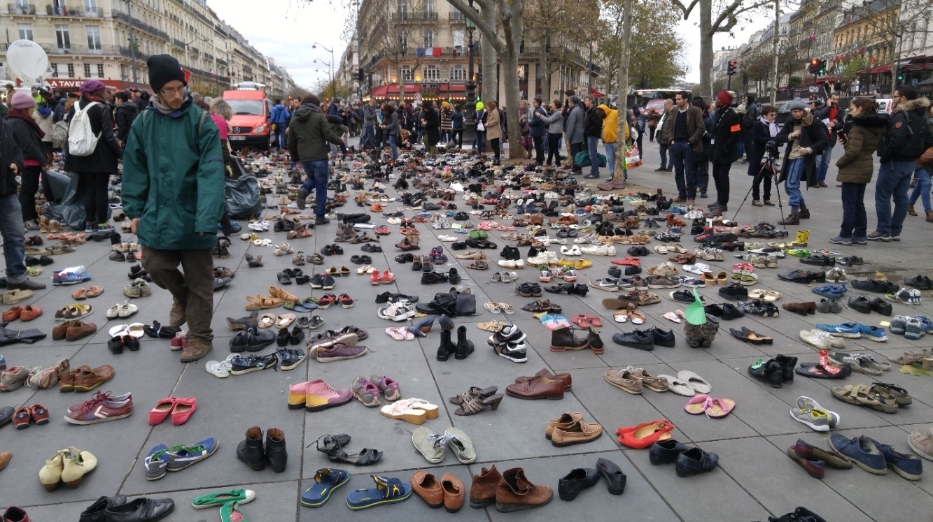

Photo: John Foran, Climate Justice Project
The Place de la République was also dotted by a couple of thousand climate activists, waving flags, dancing, and chanting. Around 1 p.m. small groups of black-clad anarchists, mostly young and mostly male, started to claim street space on one end of the square, and hundreds of police, many in full riot gear, formed ranks on the side streets on the corners. By 1:30 there was a tense stand-off with the two sides no more than a meter apart, the crowd having grown to more than 500 people. When some pushing occurred at the point of contact in one of those side streets, the first tear gas was launched, close enough so I could taste it. The crowd retreated slowly, throwing some of the shoes that they had picked up, with other projectiles, the police advancing toward the square under cover of lots more tear gas. The action ended with over 200 people arrested and many hundreds more “kettled” in by the police, who kept them there for several hours without permission to leave.

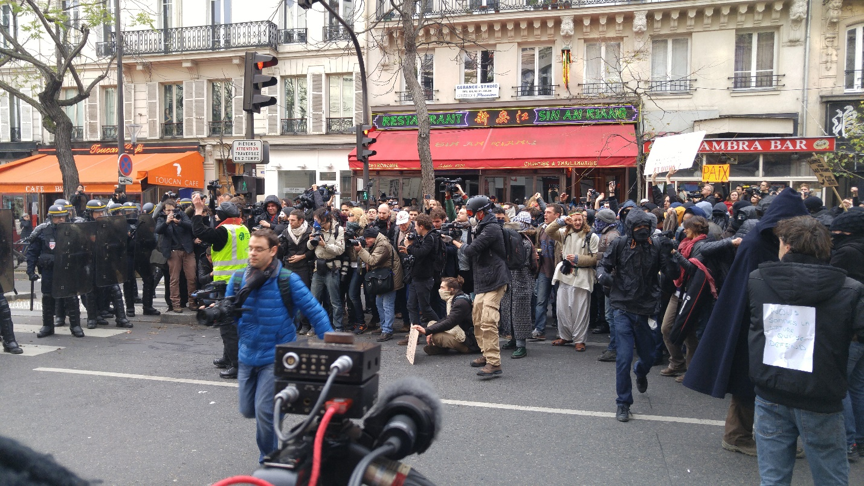

The first tear gas is launched. Photo: John Foran
Opinion was divided on the political meaning and efficacy of the actions that led to the confrontation. For a sympathetic account, see the Democracy Now! broadcast from on the spot, which clearly shows the all-too-normal brutality of the French police, who trampled on the flowers and candles of the memorial to the victims of the November 13 massacres to get at the activists. We also have a video and account from Mariah Brennan Clegg of the Climate Justice Project who was caught in the kettle, but eventually let go.
Other sectors of the movement were not so sanguine. DN! made it all about police violence but to me it felt like both sides got what they came for and I’m dubious that the climate justice movement or the planet was the winner. This signals a certain division within the movement and its links with other important struggles over what tactics are most appropriate to the tasks at hand. Emily Williams, also of our CJP, has written perceptively about this, raising the question: “As this tension builds between civil society that uses peaceful tactics and civil society that uses violence to force the hand of the state, an uncomfortable question surfaces—who is the climate justice movement?”
What’s crystal clear is that the ban on demonstrations, which is being selectively and arbitrarily enforced, is dampening down our ability -- and I think especially the ability of ordinary people -- to get their messages heard. But there are many smart people doing lots of what they do well both inside and outside the COP so their publics are getting good information and analysis. It’s more the general media story that concerns me, as movement building has to go through that route as well.
The French state is most concerned about what will happen when lots of people are angry and unhappy at the outcome on December 12. The house arrest of two dozen activists the week before the COP began and the police operation at the Place de la République are meant to send a signal to the movement and weaken its resolve. It is a very damning indictment that the French hosts of COP 21 are bent on shutting down popular participation, and that, in turn, has angered people beyond the climate movement, and should concern us all. At bottom, as former Bolivian delegate Pablo Solón said the day before the COP started, “They are using fear to hide a very bad agreement…. The Paris agreement is an agreement that will see the planet burn.”
Trying to generate momentum
As the talks started, some bold new initiatives were announced, each aimed at showing commitment to the cause by key players:
- India is going to head a coalition of 120 countries to create an International Agency for Solar Technologies and Applications (Iasta), which “aims to spread cheap solar technology across the globe with pooled policy knowledge.”
- The US and eighteen other major emitting nations, including the UK, Canada, China, Brazil, India and South Africa, “have pledged to double funds for clean energy research to a total of $20bn over five years.
- Bill Gates, Mark Zuckerberg, Richard Branson, and other global billionaires launched the Breakthrough Energy Coalition, which will combine governments, researchers, and investors to speed the global transition to renewable energies.
One can look at these announcements in various ways, with a skeptical eye noting that these are some of the countries whose national pledges fall squarely into the “inadequate” range, and a set of investors whose carbon footprints and unfulfilled past promises in the case of Branson leave much to be desired. But such a transition we do, indeed, need, and so…
One possible game changer was announced by the African group here, which set up the Africa Renewable Energy Initiative (AREI) with the goal of building 100 GW of renewable energy capacity by 2010 and 300 GW by 2030, an enormous ambition and emissions reducer considering that the total electrical generation capacity of the whole continent at the moment is 150 GW.
The Negotiations
Meanwhile, at the COP itself, the crucial body negotiating the treaty, the ADP, began its work on Sunday, November 29, giving themselves an extra day to accomplish their task. But they only worked for an hour. UNFCCC Executive Secretary Christiana Figueres said, without irony, “Never has the future of so many been in the hands of so few,” her attempt to summon courage and greatness from the assembled delegates unwittingly revealing the privilege and injustice at the heart of the process.
On Monday, and into Tuesday at noon, opening statements were delivered. There were lots of grand statements and few surprises here; instead a day and a half was lost for the negotiations. Groups representing well over 100 countries – the LDCs, G77 plus China, AOSIS, and even BASIC – reiterated their calls for a 1.5 degree limit, stating “our very survival is at stake.” Among with representatives from civil society, there was a strong call for phasing out fossil fuels and transitioning to a completely renewable energy economy by 2050. There was a common call also for a five year review of INDCs [national climate action pledges], and revisions to make them stronger in emissions reductions. The words “climate justice” were uttered by the representative for indigenous peoples – a call for climate justice that comes from “mountains, rivers, forests, oceans, and people,” saying that a two degree target would be “catastrophic” to nature and to people, and make achievement of the Sustainable Development Goals impossible. This was one intervention that received applause from the audience.
Global civil society tried, as ever, to make its voice heard, sometimes in conjunction with national parties. Christopher Loeak, President of the Marshall Islands delivered “millions of petitions calling for 100% clean energy for all” to heads of state as talks began. The first of dozens of “side events” that civil society puts on inside the COP began, as did the press conferences held during the negotiations. One of the most powerful was that of indigenous peoples, with Tom Goldtooth insisting on “The sacredness of all nature, of all of life. That is why we are suspicious of solutions coming from the hallways of the UNFCCC,” and in particular the market-based REDD centerpiece on deforestation, labelled a “deceitful scam” that trades emissions for the protection of forests. This all too often involves taking away the rights of indigenous peoples who already live there, repeating the colonial crimes of rendering the inhabitants of this part of the world invisible, or worse, taking their lives in the process. Meanwhile the purchasers continue to emit CO₂, while being hailed as contributing somehow to reducing emission.
The Climate Vulnerable Forum – now comprising forty-three countries – assumed moral leadership of COP 21 by declaring that they would achieve full decarbonization of their economies, running on one hundred percent renewable energy – by 2050, and called on the world to do so. This is big for two reasons: the CVF has more than doubled in size, now representing more than one billion people, and they have set the most ambitious emissions reductions in the world as their goal. Bangladesh’s Minister of Environment Anwar Hossain Manju issued the challenge: “We refuse to be the sacrifice of the international community in Paris. Anything that takes our survival off the table here is a red line. All parties have an obligation to act. Not doing so is a crime.” Costa Rica’s Minister of Foreign Affairs Manuel Gonzalez also had justice on his lips: “Keeping warming to a minimum – to below 1.5 degrees – won’t simply deliver safety and prosperity, it will also deliver justice.” The message that the prescription of conventionally measured capitalist growth in GDP as the way toward a just energy transition must also be given the lie.
A Strike for the Planet
On Monday, November 30 I witnessed the public launch of the student climate strike movement, joining a gathering of about twenty-five people for a day-long workshop. Organizer Kjell Kühne of the Leave It in the Ground initiative [LINGO] told us: “There’s not much time. But we have to do this, to stop fossil fuel extraction. We have no other choice. But there is hope.” In his view, hope lies in all the things that make our enemies weaker: the fossil fuel divestment movement, law suits and legal action for the climate; pushing for 100 percent clean energy; and creating an economy for the common good.
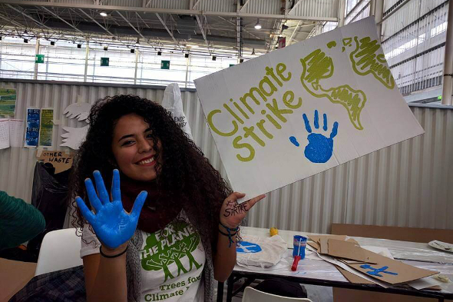
Mexican activist and co-organizer Paulina Sanchez greeted the frazzled author with a hug. Photo by Climate Strike.
Fifteen year-old eco hip-hop artist Xiuhtezcatl Tonatiuh was in attendance, and told New Internationalist reporters Marienna Pope-Weidemann and Samir Dathi, who have given us this excellent account of the day’s events, “In the light of a collapsing world, what better time to be born than now? Because our generation gets to rewrite history.” And that is precisely what this movement of students from five continents intends to do in the coming year, and far beyond.
Of Leap Years and Manifestos
On Wednesday, December 2, we went to hear the group that has spearheaded Canada’s Leap Manifesto, including filmmaker Avi Lewis, author Naomi Klein, and leaders and activists of indigenous, labor, water rights, and other movements. The “momentum of the no” that has built a series of wins against extractivism in the tar sands, the Arctic, and elsewhere in the past year, must be balanced by “a vision of the yes” that channels the deep desire for radical, ambitious and bold change. We have a choice between “The politicians locked up in Le Bourget [who] are living in a dream world,” and a politics of intersectionality that does the difficult work of building bridges between movements who have rarely worked together until quite recently, across generations, racial divides, gender lines, and classes. “A time of multiple, overlapping crises requires integrated solutions that radically build more just economies and societies based on radical equality.”
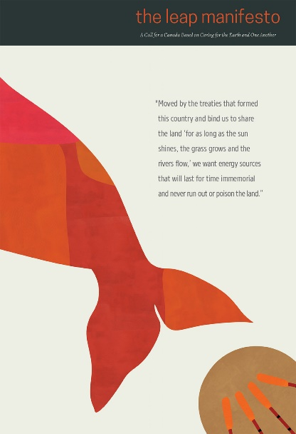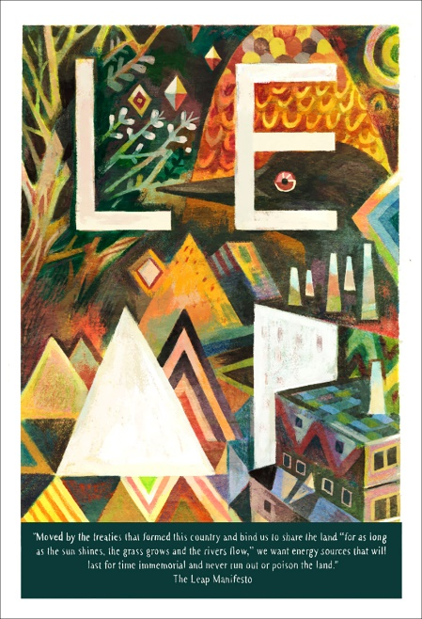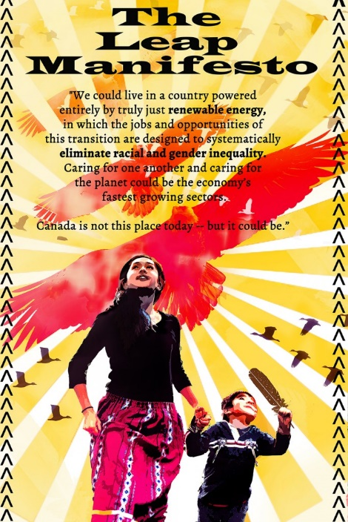

Posters by Julie Flett, Matt Forsyth, and Angela Sterritt. Click to enlarge.
Maude Barlow, of the Council of Canadians, told us to look behind the fine words of the heads of state assembled in Paris to the real agenda of COP 21, based on a globalization of unlimited growth, austerity, and secretive trade agreements while three-quarters of the world’s people cannot find permanent work with decent pay and benefits.
It is fitting to give the last word on the opening days of COP 21 to an activist described by writer Jamey Kelsey-Fry:
There is a pervasive sense of courage in the face of extreme adversity. When I ask people if they are frightened, they say that they are but that they are also completely determined, and that they are proud to be able to be here and take action. One unnamed young French woman goes further: “With climate change we are talking about unimaginable violence, violence on a massive scale. Climate change is a war, the biggest war we have ever seen. We must represent everyone and we must act now. If you do not come here to fight for climate justice, act in your own homes, in your own towns and cities.”
-- Jamey Kelsey-Fry, “To the Inflatable Barricades”
2016 is a leap year. Strange and magical things can happen on that day. May it be a whole year of leaps for climate justice.

Sources for following the COP
UNFCCC webcasts for live and recorded sessions and press conferences at COP21:
http://unfccc6.meta-fusion.com/cop21/events
Climate Action Network [CAN], Eco Newsletter, http://www.climatenetwork.org/eco-newsletters
Third World Network [TWN], “Paris News Updates,” which will be found on their website at http://www.twn.my/
International Institute for Sustainable Development [IISD], daily Earth Negotiations Bulletin, http://www.iisd.ca/climate/cop21/enb/about.html
Democracy Now! is broadcasting daily from COP 21: http://www.democracynow.org/
IBON International Updates: http://iboninternational.org/
Climate Justice Project blog posts; www.climatejustice project.com

